ASSIGNMENT OF MODULE - 1

1. What is HDLC ?

-> SDLC is one type of life cycle for software development.

-> It is a structure imposed on the development of a software product.

-> Six phases in SDLC requirement gathering, analysis, design, implementation, testing, maintenance.

2. What is software testing ?

-> Software testing is a process used to identify correctness, completeness and quality of developed computer software.

- correctness : solving the problem of users

- completeness : requirement full-fill

- quality : maintain software

-> There is two type of testing:

1. Static testing

->It can test and find defect without executing cod.

2. Dynamic testing

->In dynamic testing the software code is executed to demonstrate the result of running tests.

3. What is agile methodologies?

-> Agile is combination of iterative and incremental models.

-> When project’s future plan and next update or ways not planned then agile methodologies use for this project.

-> When project’s end don’t know then use agile model.

-> It has no planning requirement.

4. What is SRS ?

-> SRS is a compete description of the behavior of the system to be developed.

-> Types of requirement:

1.Customer requirement –

-> Know the customer’s demand

2.Functional requirement –

-> We can change that requirement for permanent.

3.Non-functional requirement –

->We can’t change that requirement for permanent.

5. What is oops ?

-> Identifying object and assigning responsibilities to these object.

-> An object is like a black box.

-> The internal details are hidden.

6. Write basic concepts of oops.

-> oop has six features :- object, class, abstraction, encapsulation, inheritance, polymorphism.

1.Object – Any entity which has own state and behaviour.

2.Class – Collection of objects.

3.Abstraction - Hiding internal details and showing functionalities.

4.Encapsulation – Wrapping up of data or binding of data.

5.Inheritance – When one object acquire all the properties and behaviour of parent class.

6.Polymorphism – Many ways to perform anything.

7. What is object ?

-> Any entity which has own state and behaviour.

Ex. Pen, paper, chair, box, ball,

8. What is class ?

-> Collection of objects.

Ex. Cars, human body

9. What is encapsulation ?

-> Wrapping up of data or binding of data.

Ex. Capsule

10. What is inheritance ?

-> When one object acquire all the properties and behaviour of parent class.

Ex. Father-son, old car-new car

11. What is polymorphism ?

-> Many ways to perform anything.

Ex. Method overloding, method overriding

12. Draw usecase on online book shopping.

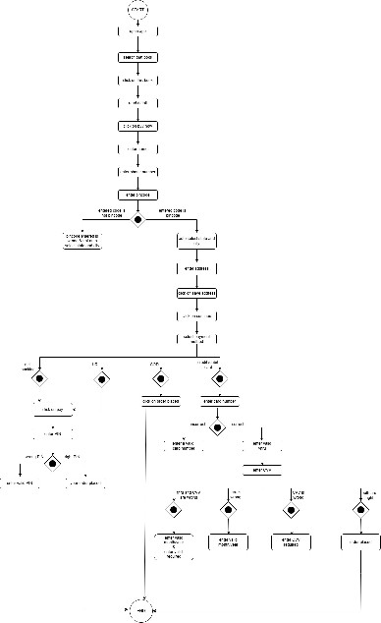

13. Draw usecase on online bill payment system (paytm).

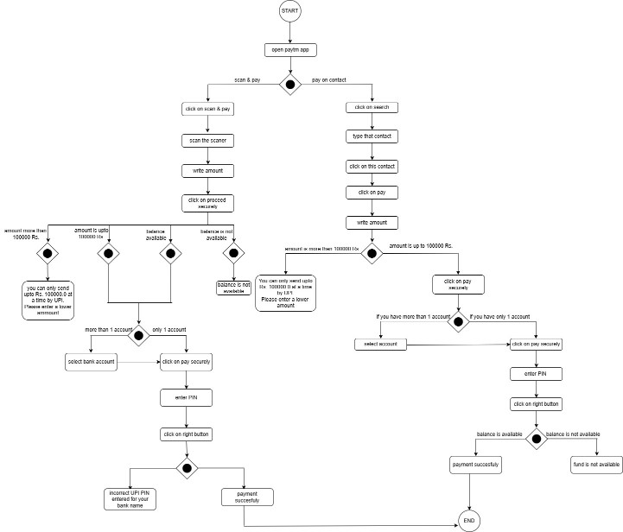

14. Write SDLC phases with basic introduction.

-> 1. Requirement gathering

Types of requirements

(i)Functional requirement

->We can change that requirement for permanent.

(ii)Non-functional requirement

->We can not change that requirement for permanent.

2.Analysis

-> Analysis represents the “what” and “how”.

->Understand that ‘what the customer wants to do?’ and ‘how customer wants to do?’

3.Design

->As per customer demand design the software.

->plan for implementation.

4. Implementation

-> Implementation means coding.

->Build the software

->The implementation phase deal with issues of quality, performance, baselines, libraries and debugging.

5.Testing

->Test that builded software.

->Find errors and repair that errors.

->If developer do test it’s call unit test.

6.Maintenance

->Types of maintenance:

(i)Corrective maintenance – identifying and repairing defects.

(ii)Adaptive maintenance – the existing solution to the new platforms.

(iii)Perfective maintenance – add new requirements.

15. Explain phases of the waterfall model.

-> Waterfall model only for small projects.

-> Requirements are fixed before start project.

-> Simple and easy to understand and use.

->High amounts of risk because there is no cganges after work.

16. Write phases of spiral model.

-> For medium to high risk projects.

-> Use only for long term projects.

-> We can change requirement with time.

-> Four part in spiral model – planning, risk analysis, engineering, customer evaluation.

-> First planning from initial requirement after that we do risk analysis and go or no-go decide that and in engineering ‘development of the product’ after that, in customer evaluation ‘assessment of the results engineering’ and alpha demo.

17. Explain working methodologies of agile model and also write pros and cons.

-> Agile is combination of iterative and incremental models.

-> When project’s future plan and next update or ways not planned then agile methodologies use for this project.

-> When project’s end don’t know then use agile model.

-> Pros :

- Little or no planning required.

- Easy to manage.

- Gives flexibility to developers.

-> Cons :

- Not suitable for handling complex dependencies.

- Not use for small or medium projects.

18.Draw usecase on online shopping product using COD.

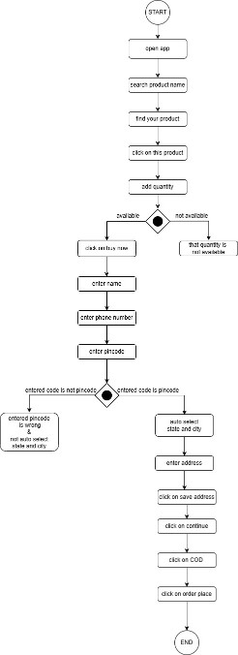

19. Draw usecase on online shopping product using payment gateway.

